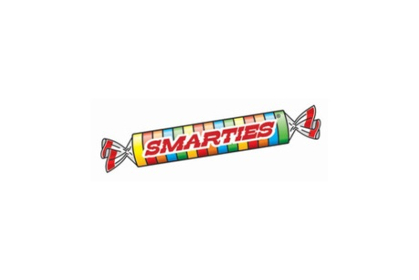
I’m a Smartie

Name________________________

One thing I have learned today is…..

________________________________________________________________________________________________________________________________________________________________________________________________________________________________________________________________________________________________________________________

I’m a Smartie

Name________________________

One thing I have learned today is…..

________________________________________________________________________________________________________________________________________________________________________________________________________________________________________________________________________________________________________________________

