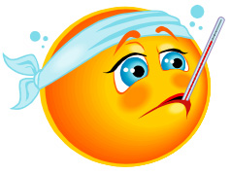
What Happened?
Book Hospital

My book got hurt because:

________________________________________________________________________________________________________________________________________________________________________________________________________________________________________________________________________________________________________________________

What Happened?
Book Hospital

My book got hurt because:

________________________________________________________________________________________________________________________________________________________________________________________________________________________________________________________________________________________________________________________

